• Connecticut • Maine • Massachusetts • New Hampshire • Rhode Island • Vermont •

Tina Smith, GFWC New England Region President
Theme: Be Bold. Use Your Voice!
October 31-November 2, 2025

116th GFWC New England Region Conference CALL
MILLS FALLS AT THE LAKE
312 Daniel Webster Highway, Meredith, NH 03252
1-844-745-2931
Conference Theme: ‘This is How We Roll’
2025 Conference Chairman:
Anne Engelhardt, annehardt@comcast.net, 603-321-9428

GFWC New England Region members,

You are officially invited to the 116th GFWC New England Region Conference hosted by GFWC New Hampshire, in Meredith, NH. Please mark your calendars for October 31- November 2, 2025, get your hotel reservation made and mail in your registration as soon as possible, please don’t wait until the last minute. Let’s take this time to celebrate this past year, learn from each other, and set goals for 2025-2026.

NEW for this CALL! We have only ONE registration and meals form, and you only have to mail that and your check to ONE place!! This is something I hoped to do this administration, and your NER officers were 100% for it. Make sure you read every page in this CALL, it is loaded with needed information regarding the weekend.

Last, I challenge each of you to bring at least one club member with you who has not attended a NER meeting before. I have set a goal (yes, another one) to have 130 registrations for this 116th NER Conference. I can not wait to see you in beautiful Meredith, NH!
In Federation Friendship,

Tina Smith, President
GFWC New England Region
603-491-4240
Tismith12@comcast.net
HOTEL INFORMATION
Mills Falls at the Lake
Address: 312 Daniel Webster Highway, Meredith, NH 03252 Telephone Number: 1-844-745-2931
If you call, please reference ‘GFWC New England Region Conference’
Direct Booking Link: https://millfalls.book.pegsbe.com/promo?propertyCode=MILLS&offerCode=3361442
Group Rate Closes September 30, 2025
Directions: ENTER 281 Daniel Webster Highway, Meredith, NH 03252 INTO YOUR GPS (Church Landing/Central Check-in)
PLEASE SEE ATTACHED MAP FOR LOCATIONS (SEE #S BELOW WHERE TO FIND HOTEL ON THE MAP)
Mill Falls at the Lake, 312 Daniel Webster Highway, Meredith NH 03252. With a collection of
four distinct accommodations that extend from the deluxe to the charming, the resort
connects guest with the lake and the breathtaking alpine surroundings.
Room Block Price includes room rate, $10 resort fee (includes free parking, high speed
internet, 24/7 coffee, tea, hot chocolate, daily newspapers, local and toll-free calls,
complimentary welcome reception on Friday afternoon, access to fitness center facilities,
pools and hot tubs) and $1.50 Meredith Village Conservation and Preservation fee.

#1 Church Landing/Central Check-in, a luxury lakefront stay, set on the stunning shores of Lake Winnipesaukee and surrounded by lush gardens and lawns, this luxurious Adirondack inn redefines rustic
elegance at 281 Daniel Webster Highway, Meredith NH 03252. Cost per night not including
the 8.5% NH State tax is $210.50 (EVERYONE MUST CHECK IN HERE) This is where meeting is held.

#11 Bay Point, a lakeside retreat perched at the end of Meredith Bay and offers break taking
views, the contemporary decor provides a sumptuous, nautical ambience for a picturesque
stay on Winnipesaukee. 1NH-25, Meredith NH 03252. Cost per night not including the 8.5%
NH State tax is $200.50

#14 Palmer Inn at Mill Falls, a restored nineteenth-century linen mill and a tumbling 40 foot
waterfall create a setting that envelops guest in an atmosphere of warmth and comfort, and
relaxation at 312 Daniel Webster Highway, Meredith NH 03252. Cost per night not including
the 8.5% NH State tax is $180.50

#18 Chase House, across the street from the Meredith Bay, offers lake views and views of the
bustling town docks at 300 Daniel Webster Highway, Meredith, NH 03252. Cost per night
not including the 8.5% NH State tax is $200.50.

UPDATE: All double bed rooms have been taken. There are only king and queen beds with sofa beds in the room.
QUESTIONS? Contact Anne Engelhardt, Conference Chairman
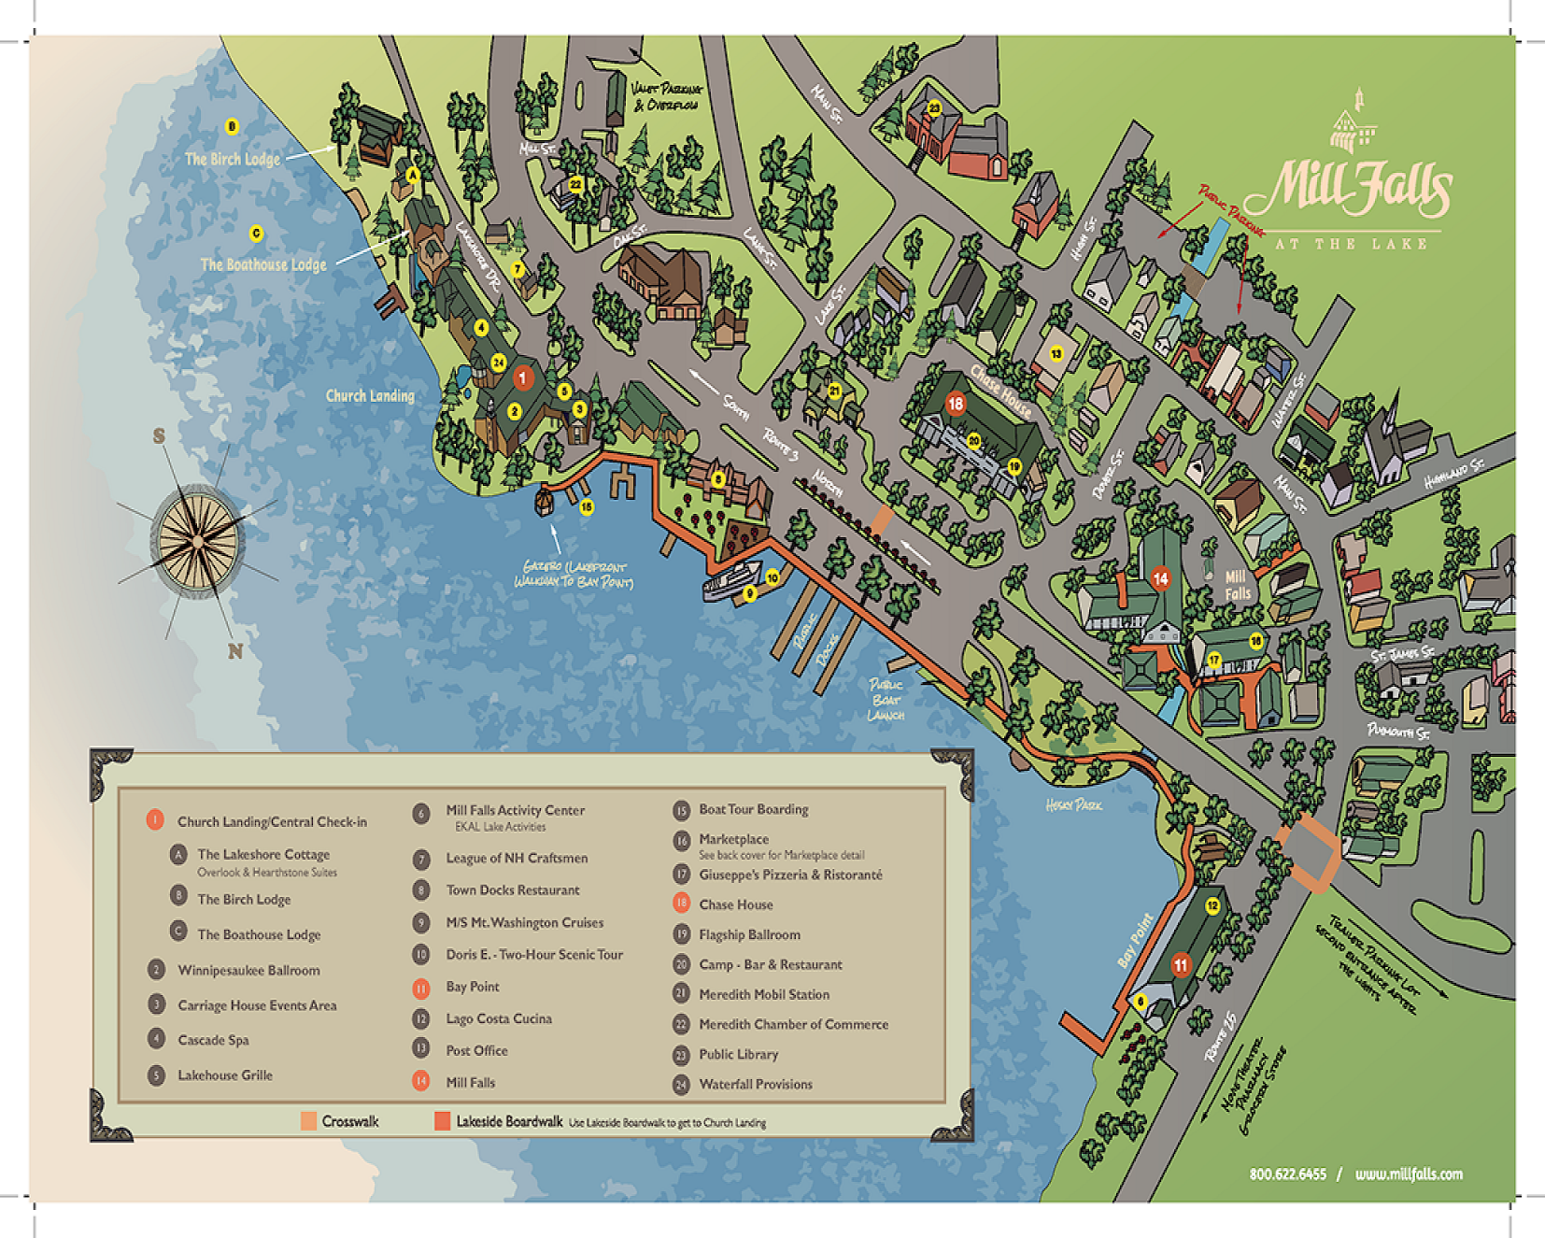

NEED TO KNOW INFORMATION
Vendors:
- 603 Sweets – Handmade Chocolate, Fudge and Candy
- Bees and Trees Farm– Gnomes, primitive sewn items, hand stamped cards, reusable heating pads
- Blue Dragonfly Custom Crafts – Layered paper Shadowboxes
- Creative Bead Studio – Silver wrapped gemstone jewelry
- Inscribed Designs– Laser Etch charcuterie boards and wooden novelty items
- JT Designs – Jewelry and wire-wrapped starfish
- KM Glass Art – Fused glass ornaments, sun catchers and pendants
- Muddy Paw Pottery – Bowls, platters, butter dishes, knickknacks and candle holders
- Scentapy – Handmade Soaps and Body Products
- The Skinny Towel & Wash Cloth Co– Made in NH Skinny washcloths, towels, recyclable grocery bags for humans and dogs.
- Ten10 Products – Cousin Dean’s hot sauces, hot honey, hot jams, hot cashews

Service Project:
There will be a card making workshop on Friday 1:00 – 2:30 PM. Drop in during this time and create a Mother’s Day Card or a card of encouragement to be given to Moms receiving services at the many agencies involved in supporting Moms and Babies. All supplies will be provided.

NH President’s Project Donation Request:

GFWC NH is asking that each state bring five (5) baby books &/or small stuffed toy, not beanie baby, to be donated to organizations that support moms and babies. GFWC NH President Denise Raisanen has created a Wish List that has books that will be donated to organization and or maternity wards.
https://www.amazon.com/hz/wishlist/ls/1AZJXUPTY7GDJ?ref_=wl_share

Junior Fun Night:
All clubwomen are invited to attend our Annual Junior Fun Night following the Saturday evening program. Massachusetts Director of Junior Clubs, Beth McKeon, director@gfwcma.org is working on a fun night of Trivia!

NEED TO KNOW INFORMATION, CONTINUED

Processional Formation:
- 8:45 am November 1, Saturday morning
State Presidents, please remember to bring white gloves, state flag, and flag stand.
Request for information for Remembrance Ceremony:
- State Presidents, please email Donna Maskwa, donna.maskwa@gmail.com, by October 1, 2025 with the names of any New England Region Past State Presidents, Dir. of Jr. Clubs or NER Presidents who have passed away since fall of 2024. Donna’s phone# if needed: (603) 502-8606

FUNDRAISING INFORMATION
Pre-Conference Fundraising Ticket Sales
Opportunity Poker Darts $5 for 6 chances
Roulette Raffle 5/$10 or 15/$20
The Roulette Raffle, sponsored by our member states, will each have a surprise within their prize.
We can’t wait to see what our states will have for us!

Silent Auction: Pre-sales are not available for the silent auction, so be sure to plan for a little extra mad money. (We will be able to take checks, cash, and credit cards with a small fee at the conference.)

ONLY AVAILABLE WITH REGISTRATION:
_____Fundraising Bonus Bundle #1 - $20
2 Hands Poker Darts
5 Roulette Raffle Tickets
_____Fundraising Bonus Bundle #2 - $35
3 Hands Poker Darts
15 Roulette Raffle Tickets
PLUS- for either bundle - Your choice of one (1) of the following:
_____1 Hand Poker Darts
_____5 Roulette Raffle Tickets

_____ Payment made via Registration Check
_____ Payment made via GiveButter

Not attending NER Conference this year?
Watch for the Select Online Silent Auction Items, open for bidding the week of conference by any member whether attending conference or not. We have some very special items that will be up for grabs thanks to our generous and creative members.
Thank you for supporting our region and allowing for GFWC workshops and information to get to our states, helping our clubs better serve their communities.
If you have any questions, please reach out to NER Fundraising Chairman, Wendy Clery at WendyGFWClady@gmail.com
Mail this form and check to: Janet Trombetti, 133 Gordon St., Cranston, RI 02910
Check payable to GFWC New England Region

CHECK THIS OUT!
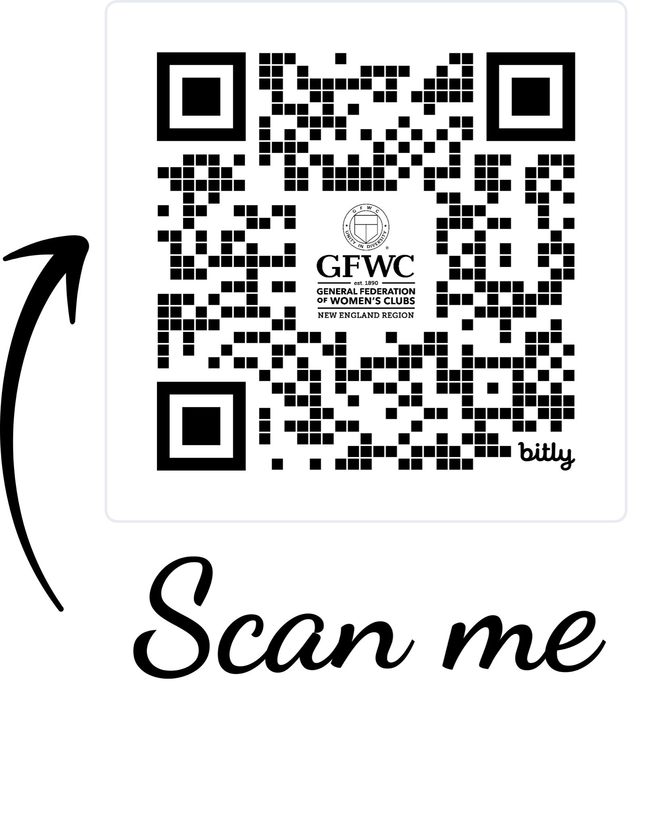

Check out fundraising and more at our New England Region link tree by scanning this QR code with your phone or at linktr.ee/GFWCNER

Fundraising through GiveButter.com - we are using this fundraising tool on a trial basis again this year. GiveButter does not charge a subscription fee for any of their many services, but they do include the covering of transaction fees with your payments. We request you cover the fees for processing, but whether you do more is entirely your decision. We want this to be a successful tool for fundraising and hope that you will find it useful. It is certainly not a requirement that you use the service, though.

Join our NER Facebook group page (Please make it easy on the administrators and answer the group questions- it helps avoid spammers and non-members getting into the group.) We will share information and fun on this Facebook group for New England members only.
You will also find the link to donate to St. Jude Children’s Hospital, the GFWC Member Portal and the GFWC Legislative Action Center!

PRELIMINARY MEETING AGENDA

Friday-October 31, 2025
9:00am – 12:00pm Registration Table Open
10:00am - 12:00pm Tours
1:00pm - 3:00pm Painting with Cheryl Sager
1:00pm – 5:00pm Vendors
1:00pm – 2:30pm Service Project (Mother’s Day Cards)
2:00pm – 6:00pm Registration Table Open
3:30pm Region Board of Directors Meeting
5:30pm Social Gathering
6:30pm GFWC NH State Night Banquet- Attire Cocktail (No Halloween
Costumes)
8:00pm – 9:00pm Entertainment JOEY VOICES
9:00pm – 10:00pm Cupcake Reception

Saturday, November 1, 2025
8:00am – 4:00 pm Vendors
8:00am – 9:00am Registration Table Open
8:45am Processional Formation
9:00am Business Session- Attire Business Casual
Reports of Region Officers
GFWC Program Presentations:
Signature Program; Juniors’ Special Program;
Community Service Programs; Fundraising; Protocol
Luncheon Recess
Guest Speaker ~ GFWC President-elect Wendy Carriker
Resumption of Business Session
GFWC Program Presentations:
Annual Giving Program
Workshops ~ Membership; Leadership; Legislation/Public Policy;
Communications
Jennie Award State Nominees
**GFWC President-Elect, Wendy Carriker, will meet with
2026-2028 Region President, State Presidents &
Director of Junior Clubs**

Saturday, November 1, 2025 (continued)

5:30pm Social Gathering
6:30pm GFWC New England Region Banquet- Attire Cocktail
7:30pm Guest Speaker ~ GFWC International President Suellen Brazil
8:00pm Entertainment DJ LORI
10:00pm – 11:00pm Junior Fun Night

Sunday, November 2, 2025
8:00am - 9:30am Breakfast Buffet- Attire GFWC Emblematic
9:30am Remembrance Ceremony
State Presidents and Director of Junior Clubs Panel
2025 LEADS Graduates
Guest speaker ~ Sexual Violence Survivor
Closing Remarks
Invitation to the 2026 New England Region Conference
Closing Ceremonies

CONFERENCE REGISTRATION, MEALS, TOURS FORM
Name: _______________________________________________________________________
Address: _____________________________________________________________________
City/State/Zip: _________________________________________________________________
Phone: _______________ Cell Phone: _______________ Email: _________________________
State Affiliation: __________ Highest Office held: _____________________________________

MEDICAL EMERGENCY INFORMATION
Emergency Contact Name: __________________________ Phone #: ___________________
Special Medical Needs: __________________________________________________________
Previously attended a GFWC New England Region Conference? [ ] Yes [ ] No
Participating in the Service Project on Friday, October 31? [ ] Yes [ ] No
PLEASE ‘X’ BELOW TO RSVP FOR DINNER OR TOURS:
_____THURSDAY NIGHT DINNER, October 30, 6:00pm
For those who arrive early and want to join us for dinner out at Hart’s Turkey Farm Restaurant, 233 Daniel Webster Hwy, Meredith, NH 03253; 1-603-279-6212; https://www.hartsturkeyfarm.com/
TOURS: (NO NEED TO PRE-PAY FOR THESE)
_____Wright WWII Museum, 77 Center Street, Wolfeboro NH 03894. Meet in the lobby of
Church Landing, 281 Daniel Webster Highway, Meredith NH 03253 at 9:10am.
Those who wish can carpool to the museum (46-minute drive). Cost is $16/adult and
$13/military and seniors. Purchase tickets at the door. Website: http://wrightmuseum.org
_____ Meredith Sculpture Walking Tour, Meet in the lobby of Church Landing,
281 Daniel Webster Highway, Meredith, NH 03253 at 10am. Includes 35 works of art in Meredith
Village. The sculptures are located on the waterfront and Main Street and showcase so
much talent and creativity. The walk is approximately 1 1/4 miles. Cost is free. Website:
http://greatermeredith.org
_____ Hermit Woods & Sweet Mercy Kitchen Wine tasting and lunch option. 72 Main Street, Meredith NH 03253. Meet in the lobby of Church Landing, 281 Daniel Webster Highway, Meredith NH 03253 at 10:35am. Tour will start at 11am (45 minutes) followed by wine sampling (45 minutes). Cost is $25. You may also choose to stay and enjoy lunch at an additional cost (ordering and paying on your own off the menu at Sweet Mercy Kitchen). Website: http://hermitwoods.com
Conference Registration Deadline: October 15, 2025
(Please use a separate form for each attendee)

CONFERENCE REGISTRATION FEE:
Entire Conference ( ) $25.00

One day or part thereof
Friday 10/31______ Saturday 11/01______ Sunday 11/02______ ( ) $15.00

MEAL SELECTIONS: (see page 12 for descriptions)

Friday Night GFWC New Hampshire State Night Banquet
Roasted Statler Chicken with Caramelized Shallot Jus ( ) $70.00 Herb Roasted Pork Loin with Pancetta Crisp and Apple Demi-Glace ( ) $70.00 Classic Vegetable Stir Fry Noodles with Fresh Vegetables in a Light Teriyaki Glaze ( ) $60.00
Saturday Lunch Buffet
Chef’s Soup & Salad Buffet ( ) $45.00
Saturday Night New England Region Banquet
Cider Braised Boneless Short Ribs ( ) $75.00
Seared Salmon with New Hampshire Mustard Maple Glaze ( ) $75.00
Butternut Squash Ravioli with Sage Brown Butter Sauce ( ) $60.00

Sunday Breakfast Buffet
Chef’s Lakeside Buffet ( ) $35.00

Watercolor Painting Workshop
October 31, Friday, 1-3pm at Church Landing, outside the Winnipeasaukee Ballroom
(Chris Craft/Bar Area). You will paint and take home four small paintings. Limited to
15 people. ( ) $20.00

TOTAL ALL ITEMS: $__________

DIETARY RESTRICTIONS (NOT PREFERENCES): _______________________________________________

Make check payable to GFWC New Hampshire
Mail these forms and check to: Carol Brauza, 77 Sheridan Street, Laconia, NH 03246
Questions? Feel free to email Carol cbrauza@gmail.com

MENU CHOICES WITH DESCRIPTIONS
Friday, October 31-Dinner

Field Green Salad with Market Fresh Vegetables and Balsamic Vinaigrette, Roasted Statler Chicken
with Caramelized Shallot Jus, Roasted Maple Sweet Potatoes, served with Chef’s Seasonal
Vegetable, Artisan Rolls and Butter, Chef’s Dessert, Locally Roasted Coffee, Tea and Soda
Field Green Salad with Market Fresh Vegetables and Balsamic Vinaigrette, Herb Roasted Pork Loin
with Pancetta Crisp and Apple Demi-Glace, Roasted Maple Sweet Potatoes, served with Chef’s
Seasonal Vegetable, Artisan Rolls and Butter, Chef’s Dessert, Locally Roasted Coffee, Tea and Soda
Field Green Salad with Market Fresh Vegetables and Balsamic Vinaigrette, Classic Vegetable Stir Fry Noodles with Fresh Vegetables in a Light Teriyaki Glaze, served with Artisan Rolls and Butter, Chef’s Dessert, Locally Roasted Coffee, Tea and Soda
Saturday, November 1-Lunch
Chef’s Soup & Salad Buffet includes Gourmet Macaroni and Cheese, Roasted Vegetables | Field Greens Salad with Market Fresh Vegetables and Assorted Dressings and Classic Caesar Salad, Sliced Grilled Chicken, Homemade Soup, Artisan Breads, Chef’s Dessert, Locally Roasted Coffee, Tea and Soda
Saturday, November 1- Dinner
Classic Caesar Salad, Cider Braised Boneless Short Ribs, Herb Roasted Fingerling Potatoes, served
with Chef’s Seasonal Vegetable, Artisan Rolls and Butter, Chef’s Dessert, Locally Roasted Coffee, Tea
and Soda
Classic Caesar Salad, Seared Salmon with New Hampshire Mustard Maple Glaze, Herb Roasted
Fingerling Potatoes, served with Chef’s Seasonal Vegetable, Artisan Rolls and Butter, Chef’s Dessert,
Locally Roasted Coffee, Tea and Soda
Classic Caesar Salad, Butternut Squash Ravioli with Sage Brown Butter Sauce, served with Artisan Rolls and Butter, Chef’s Dessert, Locally Roasted Coffee, Tea and Soda
Sunday, November 2- Breakfast
Chef’s Lakeside Buffet includes Scrambled Eggs, Crisp Bacon, Sausage, Breakfast Potatoes, Fresh
Fruit Salad, an Assortment of House-baked Breakfast Pastries, Selection of juices, Locally Roasted
Coffee & Tea

Nominating Committee Report for the 2026-2028 Administration

The GFWC New England Region Nominating Committee hereby places the following names into nomination:

For the office of Vice-President/President-elect: Arlene Creeden – GFWC Rhode Island

For the office of Secretary: Maureen Provencal – GFWC Maine

For the office of Treasurer: Debbie Fiore– GFWC Connecticut

The Nominating Committee has confirmed that all nominees are members in good standing with GFWC and meet other requirements as stated in the GFWC NER Standing Rules.

As the chairman of the Nominating Committee, I would like to thank the following committee members for their work in preparing this slate of candidates for office.
A. Elaine Brickman, GFWC Massachusetts
Kathy DeBurra, GFWC Connecticut
Darlene Remy, GFWC Vermont
Janet Trombetti, GFWC Rhode Island
Dolores VanBlarcom, GFWC New Hampshire

Submitted by,
Maureen Provencal, Chairman GFWC Maine

On behalf of the GFWC New England Region Standing Rules Committee, below are the proposed amendments to the Standing Rules. (These will be presented at the full meeting for all members to vote on)
Thank you,
Davida D. Barter, Chairman GFWC Maine
Debra A. Capuano, GFWC Rhode Island
Nancy Kalyan, GFWC Connecticut
Lorinda MacLeod, GFWC Vermont
Katie Robey, GFWC Massachusetts
Nancy Greenberg, GFWC New Hampshire

GFWC New England Region Proposed Standing Rules Amendments.
Article V. Meetings 7.a.4. currently reads:
4. The hostess state may have a separate fundraising table at the Annual Meeting to
help defray the cost of the meeting.

Proposed amendment to delete Article V. Meetings 7.a.4. and replace with the following
paragraph:
4. Any state may have a fundraising table at the Annual Meeting.

Rationale: Due to the small number or nonexistent vendors, all states should have the
opportunity to have a fundraising table.

Article VI. Duties of Officers. 1.h. currently reads:
- The President:
h. She shall recommend, upon consultation with the Treasurer, the name(s) of the
auditor(s) for approval by the Board of Directors.

Proposed amendment to strike the current Article VI. Duties of Officers. 1.h. and insert
the following to read:
h. She shall recommend, upon consultation with the Treasurer, the name of an
auditor for approval by the Board of Directors. The auditor shall not be from
the same State as the current Treasurer.

Rationale: Only one auditor is needed and to avoid any possible conflict of interest.

GFWC New England Region Proposed Standing Rules Amendments, Continued:
Article VI. Duties of Officers. 5.c. currently reads:
5. The Treasurer:
c. She shall recommend an auditor(s) to the President for approval by the Board
of Directors.

Proposed amendment to strike the word “auditor(s)” and insert “auditor.”
If adopted will read:
c. She shall recommend an auditor to the President for approval by the Board of
Directors.

Rationale: To conform with the previous amendment.

Article VI: Duties of Officers. 3.b. currently reads:

3.The President-elect:
b. She shall be authorized to plan and prepare the program of work and to make committee appointments for her administration as President. It shall be the duty of the President-elect to contact each State President for a recommendation her State’s representative for appointment to the Standing Rules Committee and Resolutions Committee. It shall be the duty of the President-elect to appoint a chairman to each of these committees.

Proposed amendment to strike the words “for a”, “recommendation”, “and Resolutions Committee”, “each of these”, and “committees”. And insert “to recommend” and “this committee”.

If adopted will read:
b. She shall be authorized to plan and prepare the program of work and to make committee appointments for her administration as President. It shall be the duty of the President-elect to contact each State President to recommend her State’s representative for appointment to the Standing Rules Committee. It shall be the duty of the President-elect to appoint a chairman to this committee.

Rationale: To conform with the next proposed amendment.

GFWC New England Region Proposed Standing Rules Amendments, Continued:

Article IX. Standing Committees first paragraph currently reads:
The Budget Committee, Nominating Committee, Resolutions Committee and Standing
Rules Committee may hold committee meetings by electronic communication.

Proposed amendment to strike “Resolutions Committee”

If adopted will read:
The Budget Committee, Nominating Committee, and Standing Rules Committee may hold committee meetings by electronic communication.

Rationale: The Resolutions Committee has no authority to present any resolutions to GFWC International.

Article IX. Standing Committees. 3. currently reads:

3. A RESOLUTIONS COMMITTEE of six (6) members with a representative from
each state, shall be appointed by the President-elect. It shall be the duty of this committee to study the GFWC Resolutions and to bring to the membership any current issue in which the women of New England can be instrumental in bringing about constructive change. The Region may, at any time during the Annual Meeting, record an opinion on an issue which has been submitted in writing. This opinion shall be regarded only as the sentiment of those present and shall not, in any way, be binding on the individual GFWC State Federations.

Proposed amendment to delete this paragraph.

Rationale: To conform with the previous amendment.

