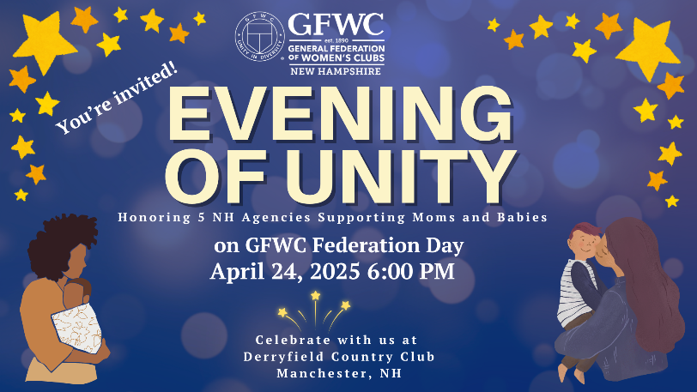

GFWC - NH
855 Hanover Street
#131
Manchester, NH 03104

March 11, 2025

Dear GFWC – NH Clubwomen.

We are now preparing for the GFWC – NH Evening of Unity/Federation Day.

Federation Day celebrates the founding of the General Federation of Women’s Clubs in 1890, 135 years ago. The Evening of Unity celebrates the GFWC – NH President’s Project, ” NH Clubwomen Supporting Moms and Babies”.

We will be honoring five NH agencies for their work supporting pregnant women, new moms and infants to create a healthy bond and a safe environment and learn life skills.

Hope you are able to attend.

Sincerely,

Denise Raisanen
2024-2026 GFWC – NH President

COME CELEBRATE NH AGENCIES
SUPPORTING
MOMS AND BABIES
And
The GENERAL FEDERATION OF
WOMEN’S CLUBS
135 Anniversary

This year’s honorees are:
Cynthia Day Family Center
Hope on Haven Hill
New Generations
Our Place
St. Gianna’s

Fun filled evening: Music Bingo and Wine Pull

RSVP
General Federation of Women’s Club – NH
Evening of Unity
Derryfield Country Club
625 Mammoth Road
Manchester, NH
April 24, 2025
6 PM – 9 PM
Organization Name: _____________________________
Name Attendee #1: ______________________________
Name Attendee #2: ______________________________
Meal Selection: ______ Pan Roasted Statler Chicken Breast
______ Seafood Stuffed Haddock
Dietary restrictions: ________________________________

R.S.V.P. by April 10, 2025
Additional Attendees:
Name: __________________________ Meal__________________________
Name: __________________________ Meal__________________________
Name: __________________________ Meal: _________________________ Name: __________________________ Meal__________________________
Name: __________________________ Meal__________________________
Name: __________________________ Meal: _________________________

Check: $55 per person
PayPal: $57 per person

Please make checks payable: GFWC – NH
c/o Mary Ryan
241 Drakeside Rd.
Unit 2202
Hampton, NH 03842

PayPal: president@gfwcnh.org $57 per meal
Email meal choice if paying with PayPal: mary27ryan@comcast.net

Any questions email Denise Raisanen, GFWC – NH President draisanengfwc@gmail.com or mary27ryan@comcast.net
603-770-0667

