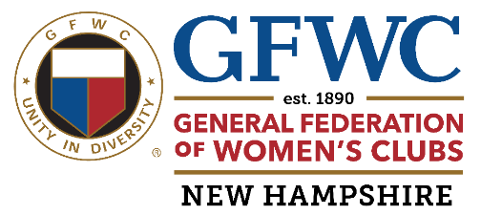

GFWC NH MINI GRANT APPLICATION

Clubs can request up to $250 in mini grants per fiscal year.
Mini-Grants will be available until funds are depleted from this account. Please check all of the items you are requesting for this grant application, not to exceed $250.00 total.
Clubs may apply multiple times during the fiscal year as long as their grant requests do not exceed $250 during the course of the year.
Please specify quantity of each item as well as total dollars requested. Once a request is approved, the GFWC-NH State Treasurer will send a check to the club. Clubs are responsible for ordering the items. Some items are available from the GFWC.org Marketplace, or you may order items on your own.
Name of Club:________________________________________________________________
Club President:________________________________________________________________
Contact Information:_____________________________________________________________
Signature/approval of Club President: _______________________________________________
GFWC Business Cards Purchase through the GFWC Marketplace which would include the GFWC logo at no additional cost. _____100 for $ 35 _____250 for $ 40
GFWC Club Meeting Branding Accessories to use while conducting your Club Meeting. Purchase through the GFWC Marketplace.
GFWC Podium Banner 14”x14” $ 30 _____
USA & GFWC Flag Desk Set $ 10 _____
GFWC gavel $30 _____
NH State flag (not available through GFWC website.) May order locally. Please note cost requested. ____
GFWC Branding /Membership/ CPR
GFWC Road sign $ 55-$250 ____
GFWC Notecards $ 10 ____
GFWC License plate frames $ 5 ___
GFWC Marketplace clothing -up to $250 ____
GFWC “ Impacting Lives of Others ” Brochures $25 _____
Club-designed Brochures or Rack Cards up to $250 _____ must use GFWC approved logos
GFWC Red or Blue logo Folders $ 2 each_____
GFWC Member milestone years of membership pins $ 5 each___
GFWC Newly branded sticky notes $ 2.50 ____
GFWC embroidered emblem patches $5 _____
State Meeting Meals -Fund cost of meals for first time attendees at GFWC NH meetings. Club will be reimbursed after member attends meeting. Honor roll meals would be excluded.
Membership in local Chamber of Commerce up to $250 ____
GFWC imprinted tablecloth/ Popup tent purchased elsewhere up to $150________
Submit this form to :Laura Otterson GFWC-NH Grants Committee Chairman
11 Gladiola Way Dover, N H. 03820 lto1949@yahoo.com 603-496-5895
revised10 /24

