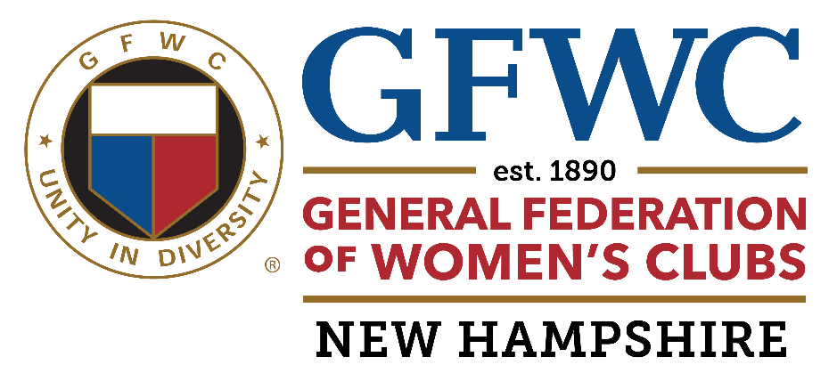

Process For Submitting a GFWC NH Grant Application

1. At the end of each GFWC NH fiscal year, the Budget Committee will determine the amount of money that will be transferred into the Grants Account.

2. Any GFWC NH club may submit an application to the GFWC NH Grants Committee. Send to: Laura Otterson, Grants Committee Chair, 11 Gladiola Way, Dover, NH. 03820
or email: lto1949@yahoo.com

3. Upon receipt, each application will be reviewed. Allow a minimum ten days for approval. Clubs will be notified whether or not their request was approved.

4. Grants must be submitted with the club’s knowledge. The club’s President signature will be required on the application. In the case of Co-Presidents, each officer will sign the application.

5. Clubs may submit applications multiple times during the GFWC NH fiscal year . Grant monies received will not exceed $1,500.00 per year.

6. Recipients will agree to use GFWC and GFWC NH logos and /or other branding on any relevant communications and public relations materials associated with the grant request.

7. Recipients will agree to report on the project upon completion through our annual reporting system and at District or State Meeting upon request.

8. The application form will be posted on the GFWC NH website and in the GFWC NH Yearbook.

9. GFWC NH must comply with 501c3 stipulations. For example, grant money may not be given to individuals.

revised 10/24

