GFWC 2020-2022 Education and Libraries

Chairman: Tina Neese, Ed.D., LPC

tinadaniel1224@gmail.com 678-458-0337
Volume Nineteen February 2022 Newsletter

Inside this edition
- ESO Facebook
Group
- Featured Monthly Book
- Talk It Up
Tuesdays
- Well Read Wednesdays
- Honorary Chairman
Others news in this edition
- Book List Recommendations
- App Ideas
- Challenge Project
- Calendar & Meeting Dates
- Resources
- Award Entries

Read All About It!

ESO Facebook Book Group
The Education and Libraries ESO Facebook Book Group meets online to discuss various books. There will be a featured book each month. The month of February features The Pretty One: On Life, Pop Culture, Disability, and Other Reasons to Fall in Love with me by Keah Brown in celebration of Black History Month. During the month on Tuesdays, readers are encouraged to post their thoughts on our “Tuesday Chats” on the ESO private Facebook page, as well as participate in the live interviews and workshops presented by the author.

Not an ESO member yet? What do I do?
Request to be added to the GFWC 2020-2022 ESO Book Club on Facebook. Order or download your book. Read and discuss the book on the group page during the month. Join the 1,000 plus members on the page who are loving the chance to read together!

In January remember these dates:
Talk It Up Tuesdays – February 7, 14, 21 and 28
Participate in discussing our book of the book

Honorary Chairman

Jane Jenkins Herlong

Jane Jenkins Herlong is Education and Libraries’ honorary chairman for the 2020-2022 Administration. Jane is an author, inspirational speaker, and entertainer. Jane is also available to encourage our women with humor and wisdom through speaking engagements.

Jane has published four books: Rhinestones on My Flip-Flops, Bury Me with My Pearls, What Ta-tas Teach Us and Bare Feet to High Heels.

Wanting more of Jane? Invite her to your state or watch her videos, such as this one: Jane.

The book for March will be “The Doctors Blackwell: How Two Pioneering Sisters Brought Medicine to Women and Women to Medicine” by Janice P. Nimura. April’s book will be “Every Little Thing” by Mary Lou Sanelli.

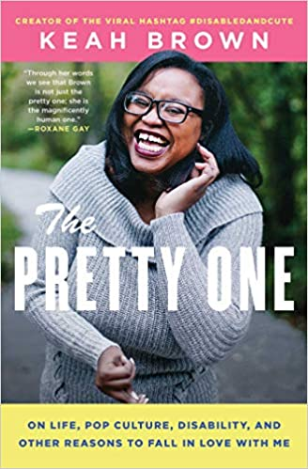
February’s Book: The Pretty One
Released in paperback in August 2019, Keah Brown’s book discusses how she came to love herself, but that had not always been the case. Born with cerebral palsy, her greatest desire used to be normalcy and refuge from the steady stream of self-hate society strengthened inside her. But after years of introspection and reaching out to others in her community, she has reclaimed herself and changed her perspective.
In The Pretty One, Brown gives a contemporary and relatable voice to the disabled—so often portrayed as mute, weak, or isolated. With clear, fresh, and light-hearted prose, these essays explore everything from her relationship with her able-bodied identical twin (called “the pretty one” by friends) to navigating romance; her deep affinity for all things pop culture—and her disappointment with the media’s distorted view of disability; and her declaration of self-love with the viral hashtag #DisabledAndCute.

“That’s the thing about books. They let you travel without moving your feet,” Jhumpa Lahiri

At various times on the ESO Book Group Page on Facebook, there will be a book list released for members to review and add to their “TBR” list. Members can comment about books on the list, giving others an idea about the book.

It is February! Here’s some books about LOVE with the top 16 famous romance novels of all time to add to your reading list:
- Pride and Prejudice by Jane Austen (this chairman’s all time favorite)
- Wuthering Heights by Emily Bronte
- Jane Eyre by Charlotte Bronte
- Anna Karenia by Leo Tolstoy
- Gone with the Wind by Margaret Mitchell (this was my first long novel I read in 7th grade that made me fall in love with romance novels)
- Doctor Zhivago by Boris Pasternak
- Love Story by Erich Segal
- Outlander by Diana Gabaldon
- The Notebook by Nicholas Sparks
- The Time Taveler’s Wife by Audrey Niffenegger
- Love in a Fallen City by Eileen Chang
- Madoona in a Fur Coat by Sabahattin Ali
- The French Lieutenant’s Woman by John Fowles
- The Princess Bride by William Goldman
- The Thorn Birds by Colleen McCullugh
- The Bride by Julie Garwood

STEM Activities for February!

February has lots of celebrations from Valentine’s Day, Groundhog Day to Black History Month and is a great time to implement some fun STEM (Science, Technology, Engineering and Mathematics) activities with children.

Here are some fun activities to try:

Try Groundhog Weather and Shadow STEM activities found at:
https://carlyandadam.com/thecarlyandadam/2020/1/30/19-february-stem-activities-for-kids-and-teachers.

Here are 28 Days of Hands On STEM for kids with recycled plastic flowers, light from lemons, and coding ideas: https://leftbraincraftbrain.com/28-days-hands-on-stem-activities-kids/.

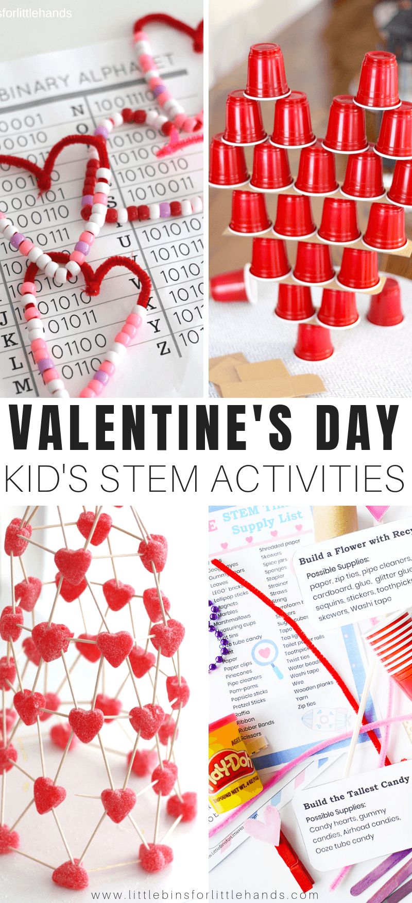
And more can be located at: https://littlebinsforlittlehands.com/valentines-day-stem-activities-challenges-kids/.

liday Activities in the Classroom
Judy Blume’s
Tales of a Fourth Grade Nothing

This month sponsor a reading of Judy Blume’s books in honor of her birthday. Find lots of free lesson plans on the internet. One of my favorite would be to have students make sock puppets and retell the story in their own words. Another idea would be to have students make mug shots of the characters. A great way to add STEM is to have students make and test paper airplanes to support the character’s desire to fly.
Technology App Monthly Recommendation:
Here’s some Valentine Day technology apps:
SendMy Gift, Nearbuy by Groupon, Epicurious, Avocado, PicCollage (looks promising and a good way to a collage), Printland, and Tom’s Love Letters

Random Acts of Kindness Day 2022

Thursday, February 17, 2022

Make Kindness the Norm

Ideas for Schools:

Locate free lesson plans at randomactsofkindness.org/for-educators

Download the free calendar for schools and supply to educators to share with students. Provide printed and bound copies for a classroom set. Each day has a simple idea to promote kindness.

Create bookmarks and give to the library.

Sponsor a kindness coloring contest.

Important Dates in February
Month of: Black History Month, 100th Day of School is usually celebrated sometime this month
Week of:
February 1 Jerry Spinelli’s Birthday (1941), author of Maniac Magee
February 2 Ground Hog Day
February 3 15th and 16th Amendment to the Constitution ratified
Elizabeth Blackwell’s Birthday (1821) first female doctor
February 4 Rosa Parks Birthday (1913)
Facebook first launched (2004)
February 5 Weatherman’s Day
February 6 Monopoly Game goes on sale (1935)
February 7 Laura Ingalls Wilder’s Birthday (1867)
Charles Dickens birthday (1812)
February 11 National Inventors Day
Thomas Alva Edison’s Birthday (1847)
February 12 Charles Darwin Birthday (1809)
Judy Blume’s Birthday (1938)
First Barbie Dolls sold (1959)
February 13 First public school established (1635)
February 14 St. Valentine’s Day
February 15 Susan B. Anthony’s Birthday (1820)
February 17 Random Acts of Kindness Day
National PTA Founder’s Day (1897)
February 18 “The Adventures of Huckleberry Finn” by Mark Twain was published (1884)
February 19 Mr. Roger;s Neighborhood debuted (1968)
February 21 President’s Day
February 22 World Thinking Day #WTD2022 Our World, Our Equal Future
February 27 Henry Wadsworth Longfellow’s Birthday (1807), poet and author of Paul Revere’s Ride
John Steinbeck’s Birthday (1902) author (The Grapes of Wrath) and Nobel Prize winner for Literature

Quotes about holidays and education:
“A good education is the greatest gift you can give yourself or anyone else.” Mahtab Narismhan
“A holiday is an opportunity to journey within.” Prabhas
“Travel, in the younger sort, part of education; in the elder, a part of experience.” Unknown
“The great difficulty in education is to get experience out of ideas.” George Santayana
“Education is the passport to the future, for tomorrow belongs to those who prepare for it today.” Malcom X

Awards! Awards! Awards!
In the next newsletters, watch for featured Top Ten projects in the upcoming newsletters.
Here’s more Top Ten:
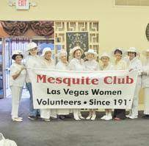
The GFWC Evening Chapter of Mesquite Club of Las Vegas (NV) adapted their annual holiday craft charity auction, which funds student scholarships, to the “Best Gala that Won’t Happen” event. Invitations were sent and donors were asked to cozy up at home, yet send donations to the scholarship fund. Three high school senior female students would be chosen to receive the $1500 scholarships. All were funded for both the current and next scholarship year.

The GFWC Sebastian Woman’s Club (FL) donated 43 pumpkins to an elementary school for a literary pumpkin decorating contest. Each classroom was able to read a story and decorate the pumpkin based on a book character. Members chose the top four out of the top ten receiving votes. The first place class, having decorated their pumpkin from their Miss Spider’s Tea Party reading, were given treats, pizza, and ice cream by the club.
TOP TEN PROJECTS – ESO
The GFWC Woman’s Club of Clayton (NC) had their ESO club members create sunflower bookmarks in recognition of the 19th amendment for Women’s Rights to Vote. The sunflower is a symbol for the suffrage movement. Members spent 10 hours creating the bookmarks and presented them to club members as a gift.
The GFWC McAlester Fortnightly Club (OK) meet monthly for their book club reading discussions and continued this tradition by moving from in person to virtual meetings with the COVID-19 pandemic restrictions. The 11 members read a combined 292 books.

Change of Address: Please note if you plan to mail the Award Entry, my address has changed as of September 1, 2021 to Tina Neese, 1213 Main Street, Porterdale GA 30070. You are always welcome and encouraged to email me the report at tinadaniel1224@gmail.com.
You may also notice I have a name change! I was married on October 2, 2021 and my name went from Tina Daniel to Tina Neese. My email tinadaniel1224@gmail.com will remain the same for this administration.
On January 23, a meeting was offered to all state chairman for Education and Libraries and for ESO to discuss the award forms.
Information for you to know:
DUE DATE:
MARCH 15, 2022
WHAT IS DUE:
- Club Creativity Award Entry Cover Sheet and one page narrative
- Award Entry Cover Sheet, ten specific projects (up to two pages) and one additional page of the state chairman’s activities
HOW TO SUBMIT:
You can submit via email at tinadaniel1224@gmail.com by March 15 or postmarked and mailed to Tina Neese, 1213 Main Street, Porterdale, GA 30070.
Examples of quality state chairman activity one page reports:
- Discusses what you did for the state
- Gives examples of what you did and be as specific as possible
- Reader clearly understands your impact in your state
Example:
As the Education and State Chairman for STATE, I was able to implement a monthly zoom meeting for all district and club chairman. All 30 clubs participated in the meetings.
or
As the state chairman, I held a state-wide workshop in the summer. The workshop’s guest speaker discussed STEM activities and how to implement those activities with students with disabilities.
Tips for describing your TOP TEN entries:
- Be specific in what the club did
- State who the club is
- Give the who, what, when, where, how and why details
- Give any information about the other organizations the club may have partnered with in the community
- Provide figures such as how many members or money donated
How to choose your TOP TEN:
Find those creative projects that really spark an interest in you and are different than what you have seen before.
Look for projects where the club overcame the obstacles of COVID. How did they meet virtually? Where they able to get into the schools or provide things to schools?
Locate those projects where the club answered the need in the community.
Read over 2021’s TOP TEN projects and rate your state’s projects.
Other Tips:
It is best if award entries are typed, as they make it much easier to read.
Make sure you are completing the award sheet completely. If handwriting this section, please print. Cursive writing does not always print well and is more difficult to discern at times. Write out the name of your state as some letters look similar when in cursive.
Make sure you are adding the additional page of your role. This is sometimes the piece needed to make a call on who wins an award.
Feel free to reach out if you have any questions.
Please give your statistical information to your state president. She will submit her State President Statistical report.

