___________________________________________________________________

The WHRC Messenger Volume 2, Issue 2, Page 1
___________________________________________________________________

GFWC Women’s History and Resource Center Committee

Hope Royer, Chairman Mary Baird Carolyn Forbes
700 Hermitage Road 11 Quail Hollow Circle 1591 Autumn Moon Lane
Manakin Sabot, Virginia 23103 Sandwich, Massachusetts 02563 Magnolia, Delaware 19963
804-784-0820 508-566-0398 302-222-6468
hoperoyer@aol.com bairdmaryc@gmail.com mrschefdjf@aol.com

******************************************************************************

Giving Tuesday, November 30, 2021

Every year, on the Tuesday after Thanksgiving, people take time to kick off the holiday season by giving back to their community. #GivingTuesday was created in 2012 as a day that encourages people to do good. Since then, it has grown into a global movement that inspires people to give, collaborate, and celebrate generosity. Join this year’s celebration on November 30, and make a
Donation to GFWC’s Women’s History and Resource Center, become a friend of the WHRC, or celebrate a friend with the gift of the WHRC Heritage Pin.

*************************************************************************************

If you are unable to attend the GFWC Holiday Open House in-person on December 8, but still want to experience
the joy of the holidays at GFWC Headquarters, at 8 a.m. ET on December 1 you can register to receive a link to the remote Holiday Open House that will launch at 5 p.m. ET on December 15. Registration for viewing the remote event will close at 12:00 noon ET on December 31.
**************************************************************************************

________________________________________________________________

The WHRC Messenger Volume 2, Issue 2, Page 2
___________________________________________________________________

The New Year brings with it the 100th Anniversary of GFWC’s purchase of 1734 N Street. In 1901 the United States Congress granted GFWC a Federal Charter requiring the organization maintain its Headquarters in Washington, D.C. Finding an appropriate location was a concern for several years, but in 1920 newly-elected President Alice Ames Winter took responsibility for locating a permanent Headquarters building. By 1922, the mansion on N Street had been identified and the GFWC Board of Directors authorized the purchase. At the 1922 Biennial Convention in Chautauqua, New York
Club women pledged over $100,000 to purchase and furnish their new Headquarters.
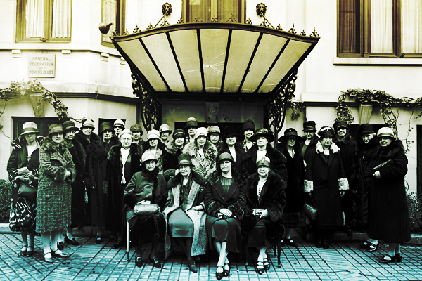
It’s time to invest in ourselves again. It’s time to invest in our future and the future of the communities that need GFWC and the clubwomen who serve them.
Why not celebrate the anniversary with a club contribution to the Capital Campaign?

**********************************************************************************
2021 Award Entries
Please encourage your Chairmen to share the WHRC Award Entry “hints” below with their clubs. They may be surprised at what can be submitted on the WHRC Award Entry!
Recording club minutes documents club history. The club’s budget inspires the future through financial support and provides community/club awareness. Does the club have a Historian, club scrapbook or even fun photographs from meetings and projects? Did you write or update your club history or use newsletters or club programs to share community/club history? Did the club recognize and celebrate member achievements on social media and in local media?
Did the club honor members for years of service with GFWC membership service pins?
Did the club honor a club/district/State Federation/Region leader with a donation to the WHRC?

*************************************************************************************

“Whoever doesn’t know the past must have little understanding of the present and no vision of the future.”
Author Unknown

