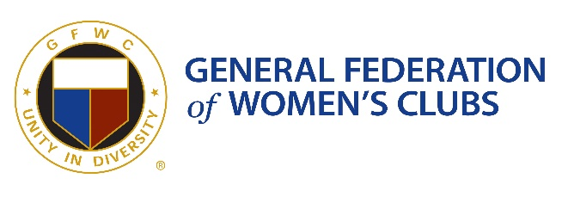
GFWC NH UNITY AWARD NOMINATION FORM
- Nominee’s Full Name or Organization Name: Click or tap here to enter text.
- Nominee’s Contact Information:
- Email address : Click or tap here to enter text.
- Phone #: Click or tap here to enter text.

- Nominator Name: (Person submitting the nomination)
- Email address: Click or tap here to enter text.
- Phone #: Click or tap here to enter text.

- Please describe why you feel this person/organization meets the criteria for the Unity Award. (See attached criteria for award)

PLEASE SUBMIT YOUR NOMINATION TO TINA SMITH Tismith12@comcast.net BY APRIL 9, 2021

