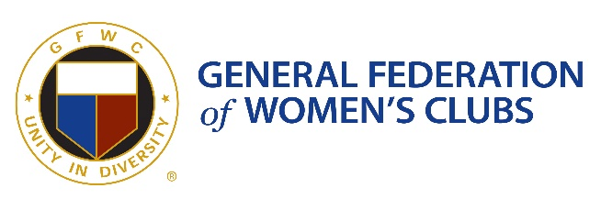

GFWC NH UNITY AWARD
GFWC NH seeks nominations for the annual Unity Award. Individuals, groups or organizations nominated for this honor have made outstanding contributions to the current GFWC NH President’s Project. The 2021 President’s Project is the Go Forth With Confidence NH Scholarship. Scholarships will be awarded to help survivors of domestic, sexual or intimate partner violence, in obtaining a postsecondary education that will offer them the chance to reshape their future by securing employment and gaining personal independence. This award will be presented at the annual GFWC NH Evening of Unity event in April.

AWARD CRITERIA
Nominations will be for an individual, group, or organization that goes above and beyond to support the current GFWC NH President’s Project. This award will honor exemplary people- those who take more risk, work harder, are more caring and thoughtful, and give more of themselves for the current GFWC NH President’s Project. In their community they are a champion for unity, peace, harmony, and oneness.

AWARD DETERMINATION
The GFWC NH Evening of Unity Planning Committee, GFWC NH President, and President’s Project Chairman determines the recipients of the award. Award recipients are determined solely on the content of the written nominations, which must be limited to 250 words.

