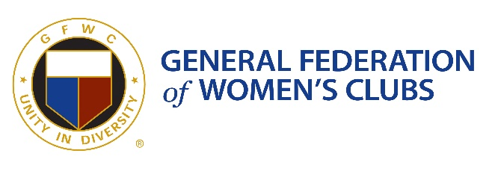
GFWC NH Evening of Unity Sponsorship Opportunities

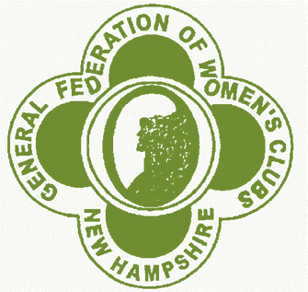Oneness $5,000.00
- Logo on posters, email blasts, and social media
- Logo on GFWC NH website
- Logo displayed during virtual event
- Verbal recognition during virtual event
Courage $2,000.00
- Logo on GFWC NH website
- Logo displayed during virtual event
- Verbal recognition during virtual event
Integration $1,000.00
- Logo displayed during virtual event
- Verbal recognition during virtual event
Harmony $500.00
- Verbal recognition during virtual event
Peace $100.00
- Verbal recognition during virtual event

