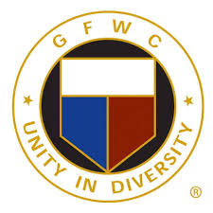
Call to
GFWC-NH
Mid Winter Meeting
January 30, 2021
Virtual Meeting

Celebrating 125 Years of Community Service

Jeanne O’Sullivan, GFWC-NH President
2020-2022 President’s Project: Go Forth With Confidence-NH Scholarship

Registration: no charge
RSVP: to Alison Dilman by January 22, 2021

Send Registration to: A2DILLRAY@aol.com

Please include the name and the email address for yourself and any other members that you may be registering for so that we can send each participant the link to the meeting. Identify your club as well. The link will be sent a few days ahead of the meeting.

8:30 am: Board of Directors Meeting
9:00-11:30: Mid Winter Meeting Preliminary Agenda

- Call to Order
- Pledge of Allegiance
- Thought for the Day
- Introductions
- Recognition of First Timers
- Preliminary Credentials
- Minutes
- Correspondence
- Treasurer’s Report
- Proposed Bylaw amendments
- Photo Contest
- Break
- GFWC NH Federation and Club Histories
- Final Report of Registration
- Announcements/Updates
- Club Collect
- Adjournment

