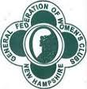
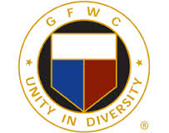
GENERAL FEDERATION of WOMEN’S CLUBS
NEW HAMPSHIRE
Celebrating 125 Years of Community Service

Jeanne O’Sullivan, GFWC-NH President
2020-2022 President’s Project: Go Forth With Confidence-NH Scholarship

Call to GFWC-NH Fall Field Meeting

Saturday, November 7, 2020; 9:00 am-12:00 pm

Via ZOOM video conference

Registration: no charge

RSVP: by October 31, 2020

Send Registration to: A2DILLRAY@aol.com

Please include the name and the email address for yourself and any other members that you may be registering for so that we can send each participant the link to the meeting. Identify your club as well.

Preliminary Agenda

Welcome & Opening Ceremonies

Business

Vote on proposed by-law amendments (see GFWC-NH Fall Clubwoman Newsletter)

Chairmen Updates

Reporting Information

Guest speaker - TBD

GFWC-NH 125th Anniversary Celebration – clubs share highlights of their club’s history

Closing

